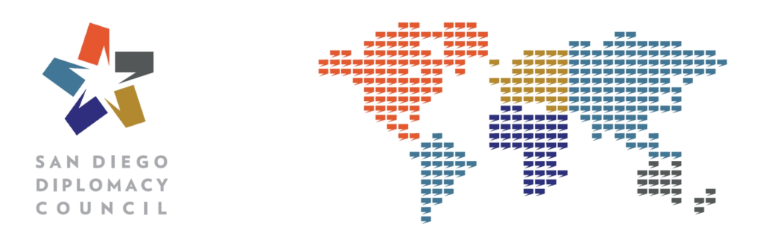
_______________________________

Project Title/Subject:
Project Type:
NPA:
Project Dates:
Point of Contact: Jessica Frank, IVLP Program Manager
(619) 291-8105
Jessica@SanDiegoDiplomacy.org

_______________________________
Why San Diego? [Brief paragraph describing key features/experience/context San Diego has to offer for this project. Incorporate stats or recent events as evidence.]

[Resource Category – duplicate as needed]
Resource Name – duplicate as needed for approximately 10-12 resources
website
Description of resource
Meeting Focus:

Resource Name
website
Description of resource
Meeting Focus:

Resource Name
website
Description of resource
Meeting Focus:

_______________________________
Cultural Activities
San Diego Zoo
www.sandiegozoo.org
Price: $58 for one Adult Ticket
The 100-acre (40-hectare) Zoo is home to over 3,700 rare and endangered animals representing more than 650 species and subspecies, and a prominent botanical collection with more than 700,000 exotic plants. Accessibility: The zoo is located just north of downtown San Diego in Balboa Park (a 5-10-minute drive from downtown).

Harbor Cruise
www.sdhe.com
Price: $28 for one Adult Ticket for a one-hour narrated tour (south bay or north bay routes); $33 for a full bay two-hour narrated tour which covers it all: ships of the Maritime Museum, Harbor and Shelter Islands, North Island Naval Air Station, the Submarine Base, as well as the Coronado Bridge, and more. The full bay tour is about 25 miles in length. Accessibility: The tour begins and ends at the same location downtown along Broadway Pier.

Old Town Trolley Tour
www.trolleytours.com/san-diego
www.oldtownsandiegoguide.com
Price: $42 for a 1-Day Adult Ticket (discounted when purchased on-line)
For 30 years, Old Town Trolley Tours has been providing sightseeing tours, highlighting the best San Diego attractions. The Tours are designed so that you can hop on and off the trolley and explore on your own at any time throughout the day. Hours of operation are generally 8:50am – 5:00pm, with later hours in the Spring and Summer. The fleet of orange and green trolleys travel frequently throughout San Diego and over the iconic San Diego-Coronado Bridge to Coronado on a continuous 25-mile loop visiting 10 neighborhoods with 10 destination stops.

USS Midway Museum
www.midway.org
Price: $22 for one Adult General Admission Ticket ($1 discount when purchased on-line).
Imagine experiencing life at sea aboard one of America’s longest-serving aircraft carriers. Visitors to the USS Midway Museum enter a floating city at sea and walk in the footsteps of 225,000 Midway sailors who served our country and upheld the American ideals of strength, freedom and peace. Guests can spend the day exploring more than 60 exhibits with a collection of 30 restored aircraft. The self-guided audio tour, narrated by Midway sailors, brings the carrier's history to life. Operating Hours: 10am – 5pm (Last admission at 4pm). Accessibility: The museum is located downtown alongside Navy Pier.

Balboa Park
www.balboapark.org
Home to 17 major museums and cultural institutions, renowned performing arts venues, beautiful gardens and the San Diego Zoo, Balboa Park has an ever-changing calendar of museum exhibitions, plays, musicals, concerts, and classes—all in the beautiful and timeless setting of this must-see San Diego attraction. Accessibility: Balboa Park is conveniently located just north of downtown San Diego (a 5-10-minute drive from downtown).

Coronado
http://coronadovisitorcenter.com
https://www.sandiego.org/explore/things-to-do/beaches-bays/coronado.aspx
A drive across the 200-foot tall Coronado Bridge treats you to one of the best views in all of San Diego, as you descend upon the charming and picturesque oceanfront community of Coronado. Consistently voted among America’s finest beaches by The Travel Channel, Coronado’s beaches glisten year around due to the mineral Mica in the sand, while gentle waves caress the shoreline. Coronado Central Beach runs along Ocean Boulevard with a backdrop of fine homes and mansions and the Hotel del Coronado at the southern end. Accessibility: Coronado is a popular stop on the Old Town Trolley Tour and can be accessed from Downtown using the Coronado Ferry or a water taxi. Coronado is a 15-20-minute drive from downtown.

SeaWorld San Diego
www.seaworldparks.com/en/seaworld-sandiego
Price: $93.99 for one Adult Ticket (discounted when purchased on-line)
Come celebrate the wonders of the sea at SeaWorld San Diego. Experience the Orca Encounter, Dolphin Days, and Sea Lions Live shows and thrilling rides like Electric Eel, Manta, and Journey To Atlantis. Feed and touch dolphins and get up-close to beluga whales, polar bears, sharks and penguins. Enjoy fascinating aquariums and exotic birds from around the world. Hours vary by season. Accessibility: A 15-20-minute drive from downtown San Diego.

